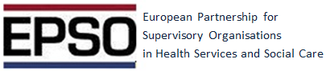

**EPSO 26th Conference 11-12th September in Sofia, Bulgaria**

Second day discussion session on topic:

**How can we change our methods the way that the inspectorate ”is a part of solution”?**

**Chaired by Klas Öberg**

Assignments for the discussions in groups were :

1. **SYSTEMATIC APPROACH- PATH THROUGH THE SYSTEM- PROSPECT AND PROBLEMS-ABILITY, DESIRE, COURAGE**
2. **RELATIONSHIP WITH STAKEHOLDERS AND PROVIDERS-PROSPECT AND PROVIDERS**
3. **DO WE NEED INSPECTORATES? ISN’T QUALITY IMPROVEMENT ORGANISATIONS ENOUGH?**

You can see the group results here (photos of posters) : <http://www.epsonet.eu/group-sessions-2.html>

**Feedback from discussions:**

**Key points out of group discussions:**

1. **SYSTEMATIC APPROACH.**

* **Legislative framework**
* **Integrated care**
* **Co-operation between supervisory authorities**
* **Patient pathways**

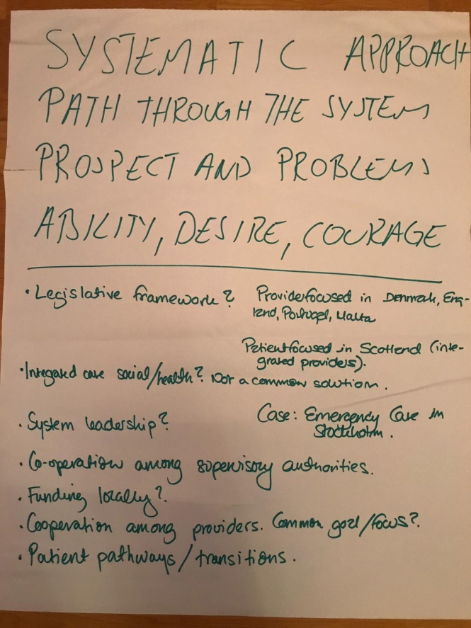 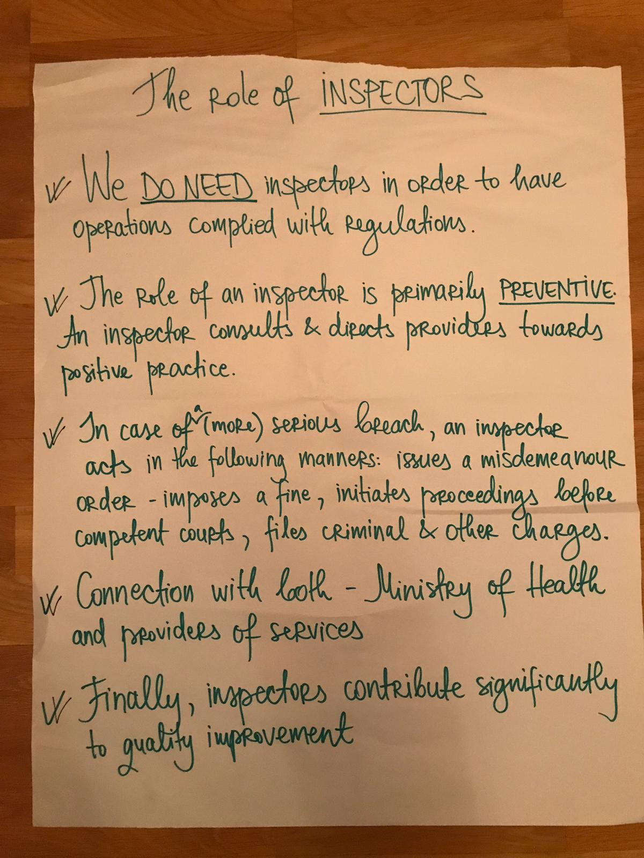

1. **RELATIONSHIP WITH STAKEHOLDERS.**

* **Be careful not to get too close**
* **Coproduction with planning and design with providers leds to more change of sustained improvement**
* **Work with providers when publishing bad news**
* **Give providers incentives for sharing good practice**

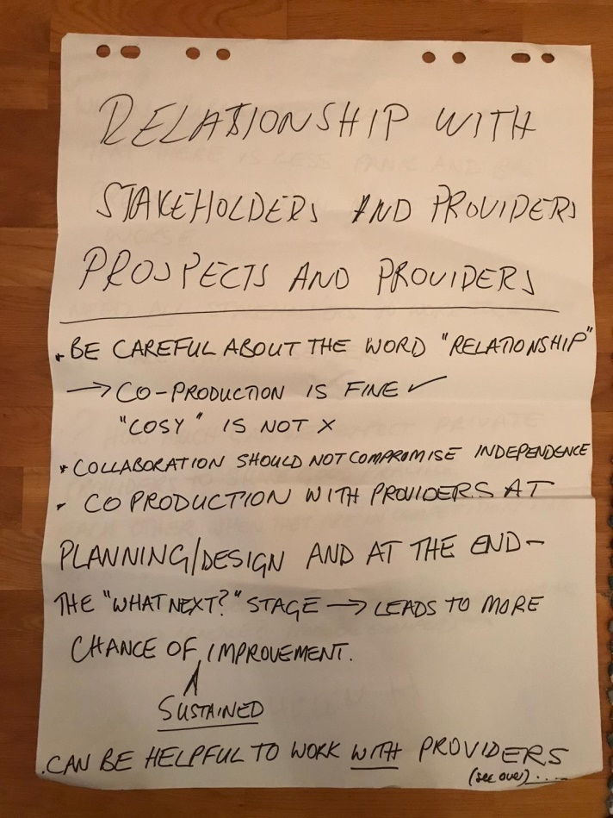 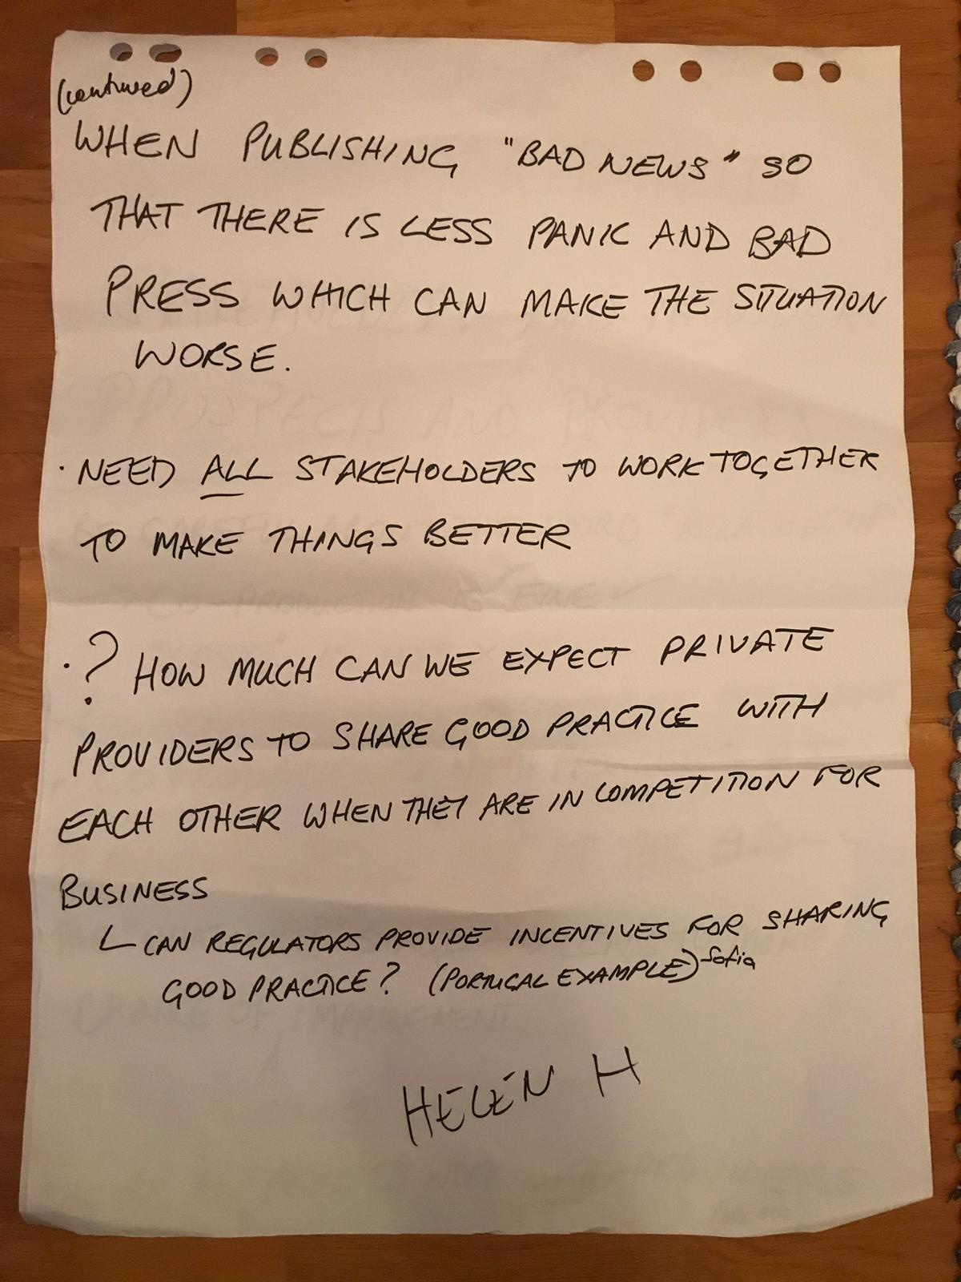

1. **DO WE NEED INSPECTORATES?**

* **Preventive force**
* **Can use a number of “tools”**
* **Connection with both the legislator and provider**
* **Gather knowledge**
* **Ensuring minimum standard**
* **Both protective and supportive**

