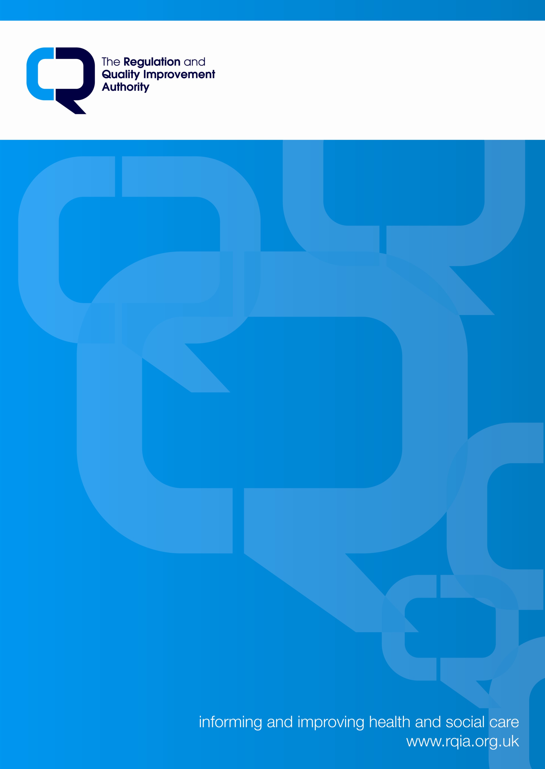

**Deinstitutionalisation/Protection of Patients Leaving Hospital and Entering Supported Living Accommodation**

* **Discussion Paper**

**Dermot Parsons**

**Head of Agencies Regulation**

**RQIA**

NI government strategy for people with learning disabilities has seen a series of public commitments to move away from institutional models of care provision to care delivery in the community.

Although targets for the closure of all large hospitals in Northern Ireland for people with learning disabilities have been missed in recent years, considerable progress with a “resettlement programme” has been made over the past decade which has seen many people now living in community settings.

This policy initiative has run alongside the UK Government’s Supporting People strategy. This strategy provides a housing support service that enables people who might not otherwise be able to sustain a housing tenancy to live in their own homes, generally by assisting with low level tasks necessary to sustain a household and support tenants with relations with formal bodies such as utilities suppliers.

The synergy between these two policies has led to many people with learning disabilities being accommodated in “supported living settings”. Some of these services consist of individual dwellings clustered together; others are buildings containing a number of single rooms with shared common spaces – in many ways not dissimilar from conventional residential care homes. The model of care delivery is ostensibly individualised to the needs of the tenants, but at times may be delivered using a rota system.

These services are delivered in locations represented as being the individuals’ own homes. As a result RQIA has looked for indicators of the service model being delivered in a manner consistent with the rights a person enjoys in their own home. In a number of services for people with complex needs, particularly for those whose behaviour is challenging, concerning issues affecting people’s rights have been identified through inspection, particularly in relation to Articles 3, 5 and 8 of ECHR.

* Tenancy rights not being upheld as people have been moved between services according to decisions made by health and care professionals
* People not having choice over where they live, or with whom they live
* Increasingly it has become evident that the arrangements for handling finances of people who lack capacity to handle their own affairs lack inadequate safeguards to protect against exploitation
* Use of physical interventions in respect of which multi-disciplinary assessment and consideration of alternatives are lacking
* Minimal evidence of real engagements with advocates.

A number of deprivation of liberty challenges have become evident, including:

* Individuals’ freedom to leave their own homes, or sometimes to move freely between the rooms of their own homes, have been restricted by means of locked doors or swipe card controlled doors. In some instances, people have been restricted to single rooms for protracted periods of times. There have been a number of situations where people have not been able to access rooms within their homes on the basis of staff decisions.
* Such detention arrangements have generally not taken account of the DHSSPS interim guidance on deprivation of liberty, but have been assented to by a range of relatives and professionals.